CENWP-OD-B 21 September 2010

MEMORANDUM FOR THE RECORD

SUBJECT: Dead chinook at Bonneville’s Adult Fish Facility (AFF).

On 21 September at approximately 0930, CRITFC researchers called Project Fisheries to report a dead chinook in the AFF. The fish was discovered on the Valve 15 return pool drain trash rack while CRITFC was setting up the facility. The fish had a notable injury. It had not been sampled by CRITFC. Information collected is provided below:

- Species – Chinook male
- Origin – unclipped
- Length – 97 cm
- Marks and tags – None present
- Marks and Injuries found on carcass – suspected marine mammal injury
- Cause and Time of Death – Unknown, presumably due to injury
- Future and Preventative Measures – N/A

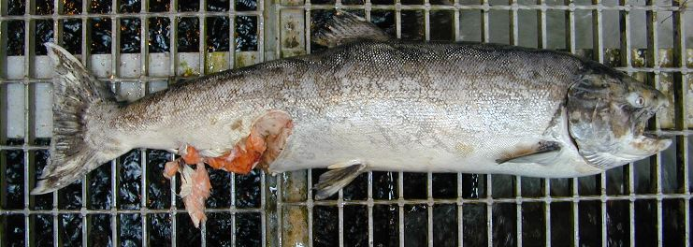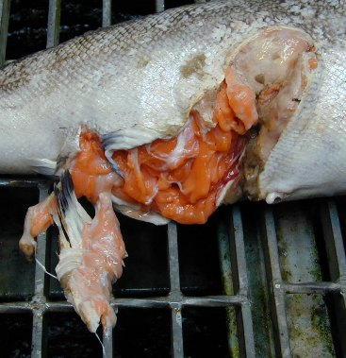

Bonneville Fisheries

